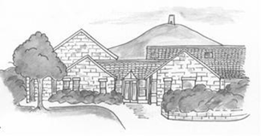

**Walton Church of England Primary School**

**Information Pack**

*Every Child, Every Chance, Every Day*

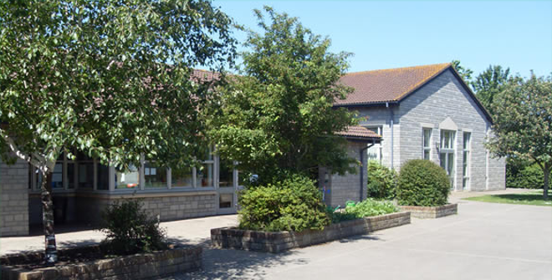

Meadow Lane

Walton

Street

BA16 9LA

01458 443675

*“I have come so that they may have life and have it in all its fullness.”*

**Walton CEVC Primary School**

Meadow Lane

Walton

Nr Street

Somerset

BA16 9LA

Tel: 01458 443675

Fax: 01458 841908

Email: Office@waltonprimary.co.uk

*Headteacher:* ***Mrs R Toal***

December 2024

**Application for Headship: Walton Church of England Primary School**

Dear Applicant,

Thank you so much for the interest you have shown in the Headship of our School. I enclose information about the school and the local community which I hope will encourage you to proceed with your application

Walton School is at the heart of Walton village, with 138 pupils currently on roll. The school has high aspirations for the success of all its pupils. It has a full complement of committed and experienced staff, who make sure that each child is cherished and cared for.

This opportunity has arisen because our present Headteacher, Mrs Rachel Toal, will be retiring at the end of the Spring Term 2025 after 16 successful and happy years here. Under her leadership significant development has occurred, however we are not content to stand still. We believe there is always potential for further improvement.

The Governing Body is seeking to appoint a Headteacher who will build on our current successes whilst bringing a fresh perspective. The Governors see this as an opportunity for growth and are looking for an inspirational leader to take the school forward.

On taking up the post, the new Head will be working closely with the Governing Body and the staff on developing the school’s key priorities through the school development plan.

The Governing Body see the Headteacher relationship as a real, working partnership; each working to support the other for the benefit of the school. Both need to demonstrate strategic thinking and activity as the school moves forward.

Governors will seek support in monitoring the quality of provision, raising standards and introducing new initiatives.

Both the Head and staff will have the active support of a full board of Governors.

We are looking for a full time Headteacher who will teach at least 1 day a week.



The school was rated as ‘Good’ by OFSTED in October 2023 and they noted many wonderful observations throughout their visit, in particular that the parents and the local community highlighted well-being as being central to life in school. They also recognised that bespoke training was available for its teachers and well-established reading programmes for pupils. They said that Walton School had a safe and nurturing culture and that its pupils were proud of their school.

I enclose a job description and person specification, which provide more details about the role. Candidates are **encouraged** to visit, look around the school and meet the staff and pupils. I would also be pleased to be available to meet you. Please phone the School Office on 01458 443675 to arrange a visit.

When writing your letter of application, please address the priorities described in the information pack. Also, please include:

               Your reasons for applying for the Headship of **this** school.

               Your experience and skills which would equip you for this role.

Your letter should be no more than two pages in length.

Your application form and accompanying letter should be returned to [**sserecruitment@somerset.gov.uk**](mailto:sserecruitment@somerset.gov.uk) and arrive no later than midday on the 29th January 2025.

Interviews will be held on Wednesday 12th and Thursday 13th of February. If you are to be called for interview you will be so informed at least one week before the interview date and your referees will then be sent a reference request.

I would like to thank you again for your interest in the post and look forward to receiving your application.

Yours faithfully

Nick Oliver

Chair of Governors



Set in central Somerset, the village of Walton is near Street, Glastonbury and Wells and surrounded by beautiful countryside including the nearby Ham Wall National Nature Reserve. Walton itself has a pub, church, village hall and playing field.

Walton Church of England School, having moved from its previous Victorian building, opened its doors at the current site in 1993. The school sits adjacent to the well-used village hall and playing field, the village hall is home to the local preschool which runs a breakfast club which pupils can attend.

The school plays an important role at the heart of the Walton community, many residents are happy to see their children and grandchildren follow in their footsteps, having attended the school themselves. The school works closely with the village’s Holy Trinity Church where they sing at community coffee mornings and hold Harvest Festival, Easter and Christmas Carol services. The school also takes part in the village’s very popular annual Family Fun Day where they show off their country dancing skills.

***About Our School – Part of The Community***

Pupils enjoy equality of learning and our approach to the curriculum is broad and diverse with a strong focus in the Arts and being active outside.

Our children are frequently recognised for being well mannered, their optimism is second only to their inquisitiveness.

Inspired by core Christian values, they learn within a nurturing and caring environment where their holistic self is valued and supported, enabling our year 6 leavers to venture into the world truly knowing themselves.

Students have the chance to learn an instrument such as the ukelele or clarinet, and take part in the school choir, there is an opportunity to perform along with other schools at the Annual Lions concert at Strode Theatre. Private piano lessons are also available.

The school hosts an annual arts week where artists come in to teach the children various skills and styles. The results are exhibited for parents to view at the end of the week.

The school encourages the children to gain confidence through drama. KS1 pupils take part in a Nativity, and KS2 pupils perform an annual play in the summer term.

The school has teams in football and netball, where they play against other schools in the local area. This helps build teamwork skills, communication and determination.

The school Well Being Action Group runs a wellbeing café that is open to the community who can come and enjoy a hot drink and talk to students. This helps build confidence in our students and fosters a strong relationship with the community.

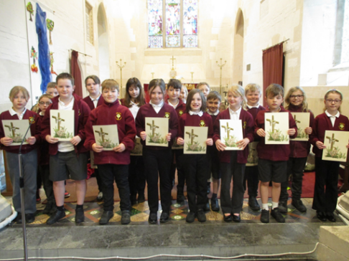

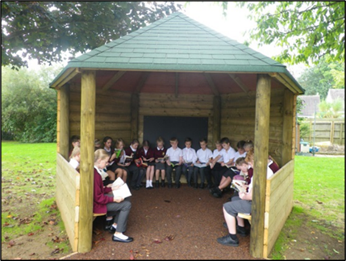



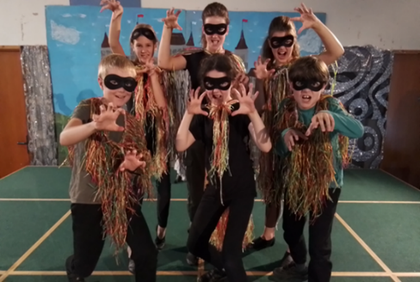

***Our Values***











Compassion

***Our Vision***

As a church school at the heart of the community, Walton Primary School is committed to provide each child with the opportunities to achieve their full potential academically, socially, emotionally, physically and spiritually. Through strong partnerships between home and school inspired by Christian values, we aim to equip the children in our care with skills and confidence to meet future challenges.

* to enable every child to feel special, encouraging them to develop their potential in all aspects of the curriculum.
* to foster self-worth so that the children will use their wisdom, knowledge and skills to make a positive contribution in the society in which they live.

* to encourage children’s respect for their environment and gain a sense of belonging and living well together within their local community.
* to provide a stimulating environment that makes learning engaging, creative and challenging.
* to give all children equal opportunities, respecting differences in culture, faith, gender and ability.
* to instil in children a sense of hope for the future, foster an aspiration to achieve well and grow in confidence so they can develop their own personal spirituality.



***What our teachers want***

***What our pupils want***



Walton School currently has 138 children aged 4-11 on roll and these children are organised into 5 mixed age classes – Owls, Swallows, Robins, Wagtails and Kingfishers. In addition to this the schools runs a Puffins After School Provision on Monday to Thursday where children can play and relax or do their homework in a supported environment for 1 or 2 hours.

Teachers are supported by experienced Teaching Assistants including 2 ELSA trained learning mentors.

The school was judged “Good” by OFSTED in October 2023 with the inspection team recognising the consistent high-quality teaching and broad range of opportunities for children.

In February 2024 the SIAMS Report found that Walton Primary School is living up to its foundation as a church school.

In November 2023 the school was awarded the Arts Mark Gold Award, recognising our commitment to arts education including music and drama.

Hot school dinners are provided daily by a local supplier. These are served in the school hall and are popular with pupils.

Forest school sessions are provided for each class and pupils take part in class music sessions ranging from choir, clarinet to ukulele.

The school is supported by a PTA who put on a number of events throughout the year to raise money for additional facilities and equipment, as well as an experienced Governing Body who carry out regular visits to the school.

The school uses Read Write Inc to support literacy and White Rose Maths to support numeracy and science throughout the year groups. In addition to this, KS2 pupils use the Accelerated Reader programme.

***About Our School***

***What Parents Say***

*“The school has excellent teachers and SENCO support which is reflected in the results”*

*“Every child I have come across has been well-mannered, kind and thoughtful”*

*“One of the strengths of Walton School is that it absolutely feels like a community”*

*“All teachers are passionate about delivering the highest standard of education to every child”*

***Our Classes***

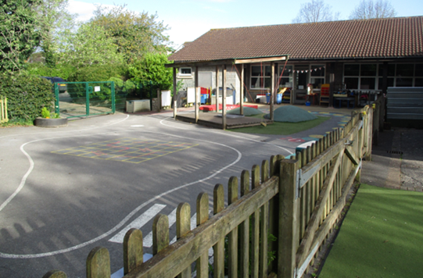

**Owls Class** is currently a mixed Reception and Year 1 class with activities taking place in the classroom and our exciting outdoor learning space. Learning experiences for Reception children are based on the EYFS curriculum, pupils develop their phonic skills using the well embedded Read, Write, Inc programme and begin their educational journey through play.

***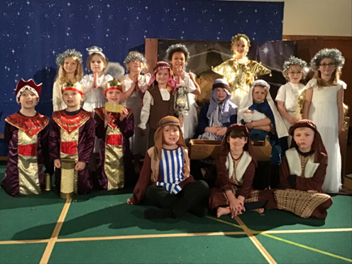*Swallows Class** is currently a mixed Year 1 and Year 2 class. The skilled staff in Year 2 take great pride in making sure the children’s learning is motivating and engaging. They learn to become independent in reading and writing so they are ready to fully access the KS2 curriculum. Excursions are taken to enrich and further develop the children’s understanding of their work.

****Robins Class** is a mix of Year 3 and Year 4 pupils. The children focus on practical activities enabling them to work independently and cooperatively.  Staff work to make everyone in the class feel valued as they move from Key Stage 1 to KS 2 and develop into successful and confident learners. As with our other classes the popular ‘TT Rockstars’ is used for daily times tables practice alongside ‘Accelerated Reader’ to track reading and comprehension.

**Wagtails Class** is a mix of Year 4 and Year 5 pupils. It is full of busy, hardworking and enthusiastic learners. They follow a varied, curriculum that involves active learning in all subject areas. Everyone in Wagtails is in the school choir with weekly lessons from a Somerset Music teacher. The children continue to build on their numeracy and literacy skills with TT rockstars and Accelerated Reader. The children are inspired to reach their full potential through a range of interactive and enriching learning experiences.

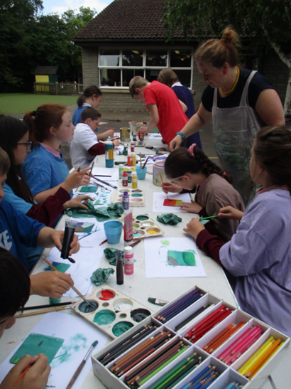**Kingfishers Class,** a mix of Year 5 and 6, are encouraged to take on greater responsibility throughout their final two years at our primary school to prepare them for the world beyond. They are Playground buddies to the younger pupils, Wellbeing Ambassadors and the Year 6 pupils are elected to the role of House Captains. The children have the opportunity to lead the Harvest Festival and Christmas Carol Services at Holy Trinity Church as well as take the lead role in their Leavers Service in July.

Whilst Year 6 are prepared for their end of KS2 SATs, their learning is not all about these national tests. They participate in the Bikeability Course, Residential Camp, the Summer Musical Production and the Year 6 Prom. Year 5 are also involved in many of these exciting events too!

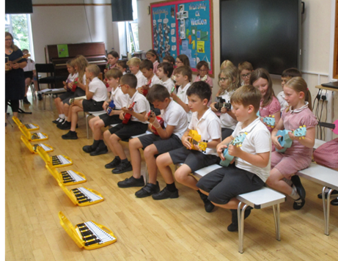All classes throughout the school have weekly PE sessions with our external sports coaches from TLE as well as weekly, engaging Art lessons. They also participate in ICT sessions using the excellent school ICT equipment and enjoy forest school sessions in our established school grounds.



**WALTON CHURCH OF ENGLAND PRIMARY SCHOOL**

**HEADTEACHER: Job Description**

**Salary Scale: ISR L8 – L16**



**Overriding Requirements**

The Headteacher shall carry out all professional duties in accordance with and subject to the "Conditions of Employment of Headteachers" set down in the Schoolteachers Pay and Conditions Document (STPC document) as amended from time to time. In particular, paragraphs 54.1 and 54.2 of the STPC document refers.

Nothing in this job description can amend, or is intended to amend, those overriding requirements.

**Job Purpose**

The core purpose of the Headteacher is to provide professional leadership and management for the School.

With the Governing Body, the Headteacher provides vision, direction and leadership for the School ensuring it is managed and organised to meet its aims and objectives. The Headteacher also seeks to secure the commitment of the wider community to the School by developing and maintaining appropriate networks and relationships.

**Key Relationships**

The Headteacher establishes and maintains effective working relationships with:

* The Governing Body
* The Local Authority
* The Diocese of Bath and Wells

and

Consults and interacts on a professional level with all Headteacher colleagues. In particular, developing and maintaining positive relationships with:

* Headteachers in the local area.
* The Headteacher(s) of Crispin Academy and other relevant secondary schools.
* Headteachers in Primary and Special Schools in Somerset.
* Early Years’ providers.
* Other services and agencies for children.

**Key Responsibilities and Accountabilities**

When appropriate, consult with the Governing Body, Local Authority, staff and parents.

**Strategic Direction and Development**

1. To develop a strategic view for the School in its community, identifying and determining its philosophy, overall aims, objectives and targets.

2. Create and develop a strategic plan for the School, underpinned by sound financial planning and management. Identifying priorities and targets aimed at raising achievement, critical to sustaining school improvement.

3. To consult, develop, implement, monitor, review and evaluate policies for delivery of agreed overall aims and objectives. Ensuring these take account of global and national trends, local and School data, and inspection and research findings.

4. Create an ethos providing a collaborative educational vision of excellence and direction which secures effective teaching, successful learning and achievement for all pupils. Including sustained improvement in their spiritual, moral, cultural, mental and physical development.

1. Continue to develop and oversee the school’s wrap-around activities and after-school clubs.
2. Ensure commitment to the school’s aims and objectives from all those involved in the School
3. Ensure the management and organisation of the School delivers its vision, aims and objectives.
4. To be the Lead Professional on Safeguarding and Child Protection for the School. Ensuring that all staff understand and practise all necessary procedures and that appropriate training takes place according to statutory requirements.

**Learning and Teaching**

1. Determine, organise and implement a diverse, flexible and appropriate curriculum for the School; within the overall framework provided by the National Curriculum and implement an effective assessment framework.
2. Ensure extracurricular activities are included in the full curriculum to enhance pupils’ total learning experience and support their broader development. The school has well established credentials in music and sports.
3. Create and maintain an environment and code of behaviour which promotes and secures good teaching, effective learning, high standards of achievement with good behaviour and discipline.
4. Monitor and evaluate the standards of teaching and learning in the School. Ensuring that appropriate standards of professional performance are established and maintained with underperformance at all levels being challenged and rectified.
5. Assess, monitor and evaluate the curriculum in order to identify and act upon areas for improvement and to develop a personalised learning culture within the school.
6. Produce and revise as appropriate a School Development Plan relevant to the needs and development of the pupils, incorporating both available and potential resources.
7. Monitor and evaluate the quality of learning and teaching in the School including Special Educational Needs. Using data to support and implement strategies for ensuring inclusion, diversity and access.
8. Develop and maintain effective partnerships with parents, carers, the community, other academies and schools, Clergy and the local worshipping communities. Extend pupils’ learning experiences, their achievement and personal development by creatingeffective links with business and industry.
9. Participate, to such an extent as may be appropriate and in consultation with the Governing Body, in the teaching of pupils in the School, including the provision of cover for absent teachers.

**Leading, Managing and Deploying Staff**

1. Take the lead role in the selection and recruitment of the teaching and support staff in seeking to ensure the best available people are appointed.
2. Manage arrangements for the deployment and effective allocation of work to, and supervision of, all teaching and support staff in the School. To maximise their skills and contribution to the improvement of the quality of education provided and standards achieved.
3. Implement and sustain effective systems for the management and induction of staff performance, participating in arrangements for the appraisal of his/her own performance and the appraisal and performance management of teaching and support staff as appropriate.
4. Lead professional development of the staff by example, ensuring that all staff have access to relevant advice, training and development opportunities. Including needs identified through Performance Management systems in accordance with the policies of the Governing Body, the School Development Plan and of the Authority.
5. Ensure that teachers at the School receive all information they need in order to carry out their professional duties.
6. Ensure that professional duties and conditions of employment as set out in the STPC document, including those for the Headteacher, and national and local conditions of service for teachers and support staff are fulfilled.
7. Develop and maintain a communication and decision making structure providing opportunities for staff participation, including the use of formal procedures to solve problems and resolve conflict.
8. Foster and maintain relationships with organisations representing teachers and support staff.

**Deployment of Resources**

1. Set priorities and targets for expenditure, allocate funds and ensure effective administration and management of all school resources.
2. Ensure the sound financial management of the school in accordance with relevant regulations.
3. Make arrangements for security and effective supervision of the School buildings, their contents and School grounds. Ensuring that such resources are managed to meet the needs of the curriculum and comply with all relevant Health and Safety Regulations.
4. Manage, monitor and review the range, quality, quantity and use of all available resources in order to improve the quality of education, improve pupils' achievements, ensure efficiency and secure value for money.

**Accountability**

1. To be accountable for the for safeguarding and welfare of children and all stakeholders using the school.
2. To be accountable for the efficiency and effectiveness of the school to the Governing Body, the Local Authority and the Diocese of Bath and Wells.
3. At all times to fulfil the tenets of the Trust Deed.
4. Foster and maintain good community relations by implementing School policy and liaising with Local Authority and Diocesan officers where appropriate.
5. Present a coherent, understandable and accurate account of the School's performance in a form appropriate to a range of audiences including governors, parents and carers. Maintaining and providing adequate and appropriate records, statistical data and returns.



The School’s website – [www.waltonprimary.co.uk](http://www.waltonprimary.co.uk)

The School’s **OFSTED** report - <https://reports.ofsted.gov.uk/provider/21/123776>

The Walton Parish Website - <https://waltonsomerset-pc.gov.uk/>

The School’s **SIAMS** Report - <https://www.churchofengland.org/about/education-and-schools/church-schools-and-academies/siams-inspections>

