**Position of Headteacher**

**Combe St Nicholas CofE VA Primary School**

Combe St Nicholas, Chard, Somerset TA20 3NG

Somerset

Telephone: 01460 63116

Website: www.combestnicholascofeschool.co.uk

Recruitment Pack Contents

Education with care 2

About the School 3

Diocese of Bath & Wells 4

Job Description 5

Job Specification 7

## Education with care

At Combe St Nicholas School, we aim to provide a happy, caring, well-ordered and stimulating environment in which teaching and learning can flourish and where all members of the school community are valued equally as individuals.

We aim to foster a close relationship between the school, families and the local community. As a church school, we promote Christian values and take seriously our responsibility for the moral and spiritual well-being of the children.

We are a small school and it is important that we build community by connecting to all those that have an interest in it. In order to create medium term strategic growth of the school we need to ensure that we are highly visible and engage with our local community



To achieve this aim we seek to create conditions which will:

* build pupils’ confidence and self-esteem
* help pupils develop lively and enquiring minds
* instil respect and tolerance for other people and the environment
* help pupils communicate effectively
* help children develop appropriate relationships with others
* facilitate enjoyment in learning now and in the future

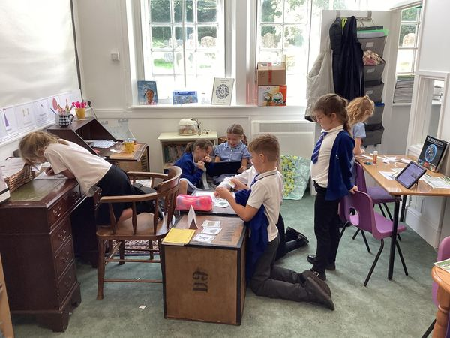

## About the School

We are a small rural school, with an excellent pre-school. Our current establishment is 101. The school is divided into four classes. The ground floor of the main building contains the KS2 classrooms and a room we keep free for group teaching and collective worship, cloakrooms/toilets and school office. There is an outbreak classroom which we are developing as a specialist science classroom.

The first floor houses the Head’s office, the staff room, a meeting room and a comprehensive curriculum resources room.

The newer building was completed in 2008. This is now our free flow EYFS Centre where Reception and Nursery children learn together providing academic challenge for those children that are ready, and additional support for those that need it. There is a dividing wall that allows the space to be separated when targeted learning is required. The nature of the way our EYFS children learn together fully supports the transition into school life. The building also contains kitchen facilities for the provision of hot school lunches, and cloakrooms/toilets. There is an outdoor area specifically catering for the Pre-School Children and then a further area for both Reception and Pre-School Children.

The children’s playground consists of various play equipment and open space for playing ball games. There are various outdoor learning areas and specialist fixed play equipment, eating areas and picnic benches There is a school field and a village hall, both of which are used for PE lessons. We visit nearby woodland for Forest School activities.

Our Ofsted inspection in 2022 gave us a continued Good rating, and our aim is to continue with our strong curriculum.

We have a Governing Body who provides strong support to the school and Headteacher

## Diocese of Bath & Wells

## Church Distinctiveness

We welcome applicants from all faiths, and none, but any applicant will need to be able to lead and support the Christian Distinctiveness of the school.

Our local vicar leads Collective worship at the school and the church is used for celebrations, music concerts and other annual festivals.

The school has services in the church throughout the year, including Harvest Festival, Christmas and Easter. Our School Vision reads:

***'THAT THEY MAY HAVE LIFE, LIFE IN ALL ITS FULLNESS' (John 10:10)***

When Jesus spoke the words: ‘I have come to bring life in all its fullness’ to his disciples; he had a vision for them that went beyond what they could see at that moment in time.

At Combe St Nicholas Church of England School, we have that vision for all of our children. We want every lesson, every experience and every day in our school, to expose our children to an education without limits – full of the joy and abundance of life.

Our vision extends beyond the school gates, where we hope to see our community touched by the values lived by our pupils. We believe that in walking through life together we can flourish together, creating the best opportunities and outcomes for all.

This vision underpins everything that we do at our school. We believe that our Christian distinctiveness enhances our care and aspiration for every individual child, drives our goals for success and enables us to teach our children how to live well. We are looking for a leader who shares this vision.

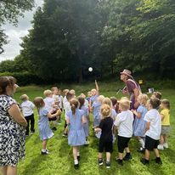

## Job Description

To fulfil all the requirements and duties as set out in the 2020 Headteacher Standards; [Headteachers' standards 2020 - GOV.UK (www.gov.uk)](https://www.gov.uk/government/publications/national-standards-of-excellence-for-headteachers/headteachers-standards-2020) and to achieve any performance criteria, objectives or targets agreed with or set by the School's 2023 School Teachers' Pay and Conditions Document.

**Safeguarding**

As a Governing Body our number one priority is the safety of the children who attend the school. As a Headteacher you will be the Designated Safeguard Lead and will need to be highly confidential and professional in how you manage sometimes challenging situations. The applicant will need to be well versed in their safeguarding duties including but not limited to KCSIE. The school currently has excellent safeguarding practices, and these will need to be maintained and kept up to date by the new Headteacher.

**Community Engagement**

As a small school parent engagement and communication is paramount to its success. It needs a strong Headteacher to lead it forward and grow it in a way that listens to the parents of the children that attend it.

**Strategic Thinking**

We are looking for a Headteacher that will understand the importance of strategic planning. They will need to continue to build and maintain our existing strong curriculum whilst ensuring they spend equal focus and time on the strategic growth of the school.

We want a Headteacher who will engage with the community and increase the schools offer through expanding on forest school and sporting opportunities.

**Our Staff**

As a small school you will need to work closely with all the wonderful staff and in particular build a strong relationship with our Business Manager, who will be critical to supporting you in your duties as Headteacher.

**SEND**

The school has a long-standing reputation for being an excellent setting for children with SEND. We wish to maintain this and ensure all children are given equal opportunities. We have a SENCO one day per week and an ELSA who works with SEND children and children in need of emotional support.

**Financial Planning**

In a highly challenging financial landscape, the school whilst in a strong position compared to many still faces financial challenges. Any Headteacher will need to be able to take challenging decisions based on accurate information and communicate these to the community in an open and transparent way. They will also need to be creative in exploring opportunities for support from the community and through raising funds in novel and new ways.

**Behavioural Management**

As part of our duty of care to the children that attend the setting, we employ a Behaviour Policy. This involves the use of consistency through all elements of behaviour management: language, follow up, positive reinforcement. We expect any applicant to continue to use this approach and be emotionally intelligent and forward leaning in this area.

## Job Specification

|  | Essential | Desirable |
| --- | --- | --- |
| Qualifications | Qualified Teacher Status  Relevant Safeguarding training  Prevent training | NPQH, CEPQH Certificate or equivalent  Paediatric First Aid  Designated Safeguard Lead training |
| Experience | Recent experience in senior leadership within a school setting.  Evidence of recent and relevant professional and personal development in preparation for this post.  Teaching experience across the primary age range including effective assessment methods.  Experience in the use of a variety of forms of pupil assessment, including monitoring, tracking, data analysis and assessment and to utilise this information with the staff to set and monitor targets for pupil progress and outcomes.  Collaborative working and relationship building with a broad range of stakeholders both inside and outside the school.  Big picture thinking: showcasing how you’ve made improvements to a schools structure or approach to use of resource.  Experience of leading and managing a diverse team combined with the ability to nurture and sustain outstanding teaching and learning.  Experience of working within the SEND environment including the EHCP process.  Experience of managing school finances within constrained budgets for the benefit of the school.  Experience of positive relationship and behavioural management techniques.  Demonstrable commitment to the social and emotional wellbeing of pupils leading to strong achievements. | Experience of coaching or mentoring.  Experience of working in more than one school.  Experience of using MyConcern software.  Experience of using LA Maintained School systems for reporting purposes.  Experience of working with a Governing Board in an open and transparent manner, enabling them to perform their strategic role effectively resulting in continuing school improvements. |
| Professional Knowledge | An in depth knowledge of the statutory duties, responsibilities and procedures with respect to safeguarding children.  Demonstrable knowledge of how children learn and how this translates into high quality teaching and learning for every pupil.  A working knowledge of school governance, including providing suitable data in a meaningful form that enables Governors to hold school leaders to account.  A thorough knowledge of all statutory requirements including the national curriculum, assessment and Ofsted frameworks.  Knowledge of the Early Years Foundation Stage curriculum.  Knowledge of and commitment to the promotion of diverse and inclusive schools and society.  Be fully supportive of, and committed to, the aims and vision of a Church of England school and be able to demonstrate the ability to lead and maintain the religious character of the school.  Understanding of British Values | Up to date, broad, knowledge of the national agenda for schools, particularly with regard to school structure and funding.  Awareness of Maintained Schools support systems. |
| Professional Skills | Excellent oral and written communications combined with strong data analytics abilities, resulting in an ability to analyse, produce and present information to a variety of audiences.  The ability to promote positive behaviour for learning and to ensure effective programmes for pupil behaviour, guidance, support and welfare are in place.  Understanding of tools and techniques to manage and support the wellbeing of all staff. | A strong track record of improving school performance through the use of a selection of school improvement strategies and knowledge of school performance and priorities. |