**Midday Supervisor Job**

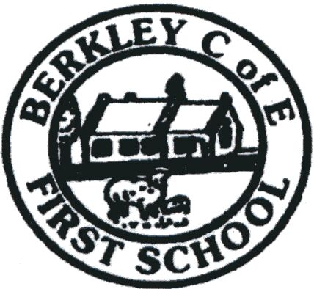

School Vision

We are a small school, with big ideas, adopting a creative approach to ensure that every child is supported in order to flourish and thrive; to see and develop their true potential.

Our vision and ethos of the school is based on the sermon of the mount, Matthew 5:14- 16; “You are the light that gives light to the world. In the same way, let your light shine before others, live so that.they may see your good works.”

We are children of the community and guided by Faith

*‘Let your light shine’*

**Description**

**This job description may be amended at any appropriate time, following consultation between the Head Teacher and the Post holder, and will be reviewed annually.**

***Main responsibilities;***

* Assist in the dining hall and encourage pupils to eat their chosen meal or packed lunch
* Setting up and clearing away tables and general cleaning duties
* To encourage good eating practices, e.g assisting pupils by cutting up food for younger pupils
* Commitment to the safeguarding and welfare of all pupils.

***Professional responsibilities;***

* Attend and complete all training as required
* To understand and comply with school’s procedures and policies
* Report any issues to the school office
* To deal sensitively and calmly with children at all times
* To maintain confidentiality at all times
* To have a flexible approach to roles and responsibilities within the team

The above list is not an exhaustive list and any other reasonable duties will be expected to be undertaken.

Our school is committed to ensuring a ‘Safe Recruitment’ process including a Criminal background check.

*We follow a safer recruitment process and Berkley First School is committed to safeguarding and promoting the welfare of children and young people and expects all staff and volunteers to share this commitment. All applicants will be subject to a full Disclosure and Barring Service before appointment takes place. Candidates are encouraged to read our Safeguarding policy before applying.*